Nathaniel Sipple

Professor Torres

9/6/2025

IT 0100

Lab 3

* Copy parts A, B, and C from Canvas
* Add notes and screenshots
* Can you reproduce the lab with the questions and your screenshots with notes?
* If your boss asked you for this, did you provide the answer with context?
* The purpose of this lab is to understand how to access hardware information on your system

#### Part A: Log on to "EACH" system in [NDG A+ v4, Lab 1](https://netlabve2.flc.losrios.edu/)

#### [Links to an external site.](https://netlabve2.flc.losrios.edu/)

* Gather hardware information using the GUI processes listed below:
  + Task Manager
  + 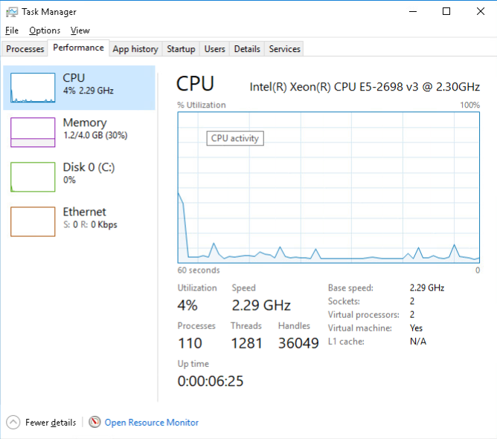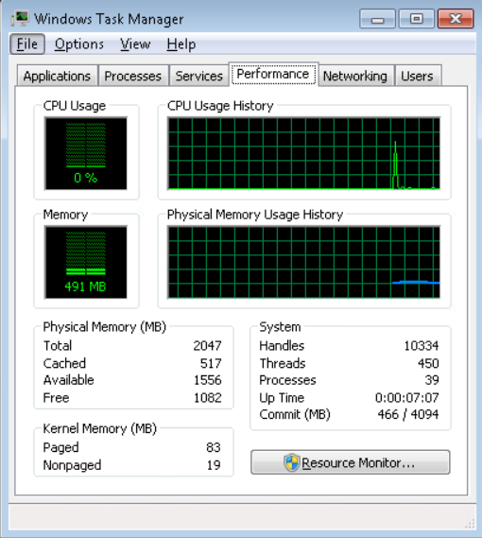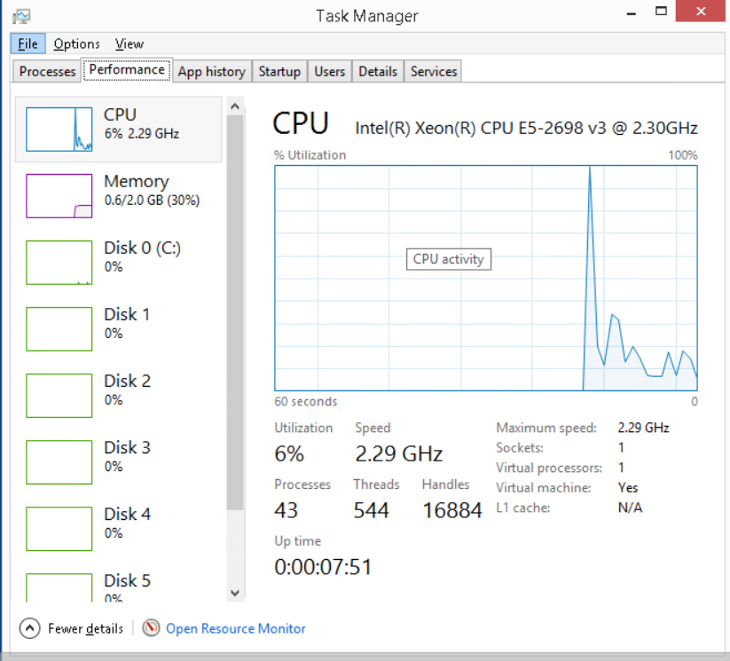
  + Device Manager
  + 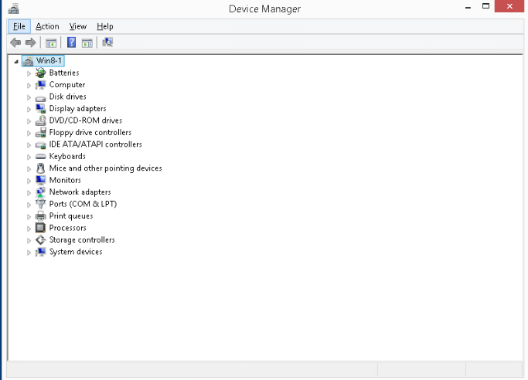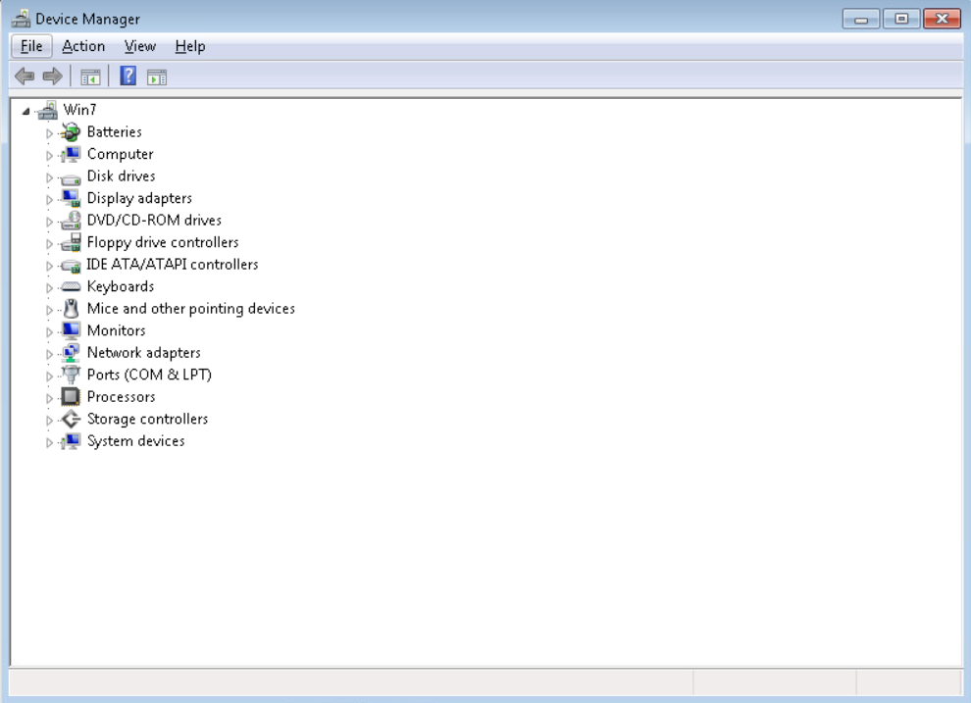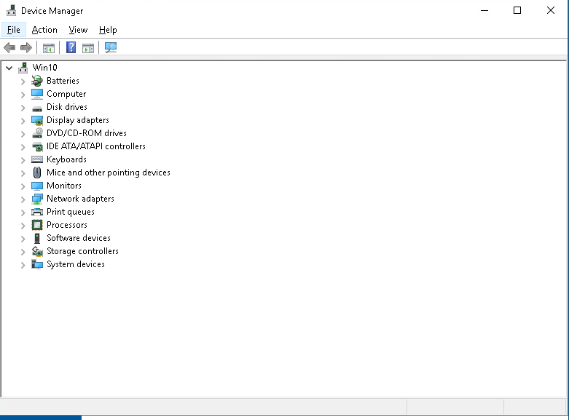
  + Resource Monitor
  + 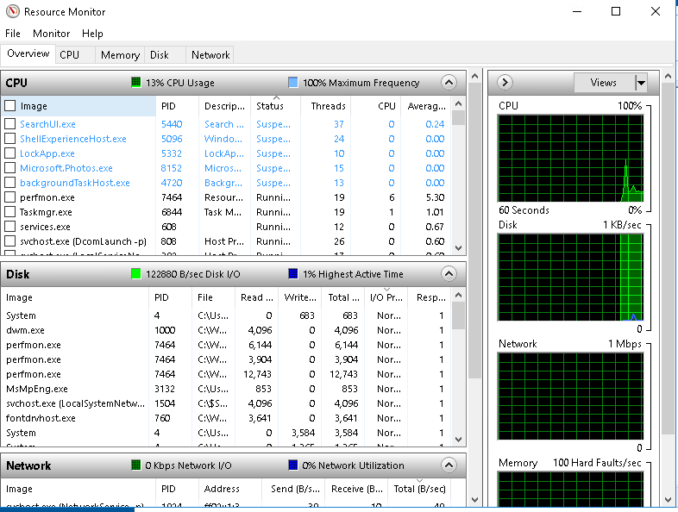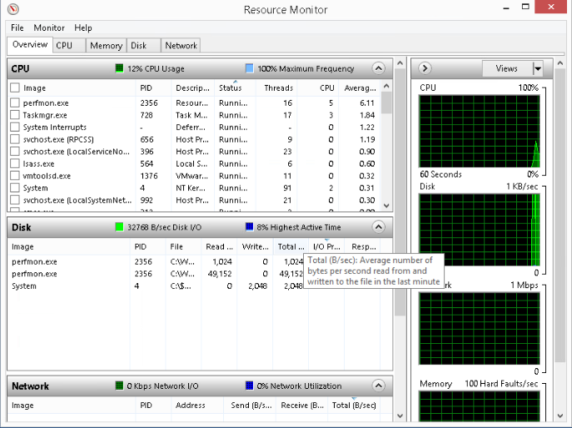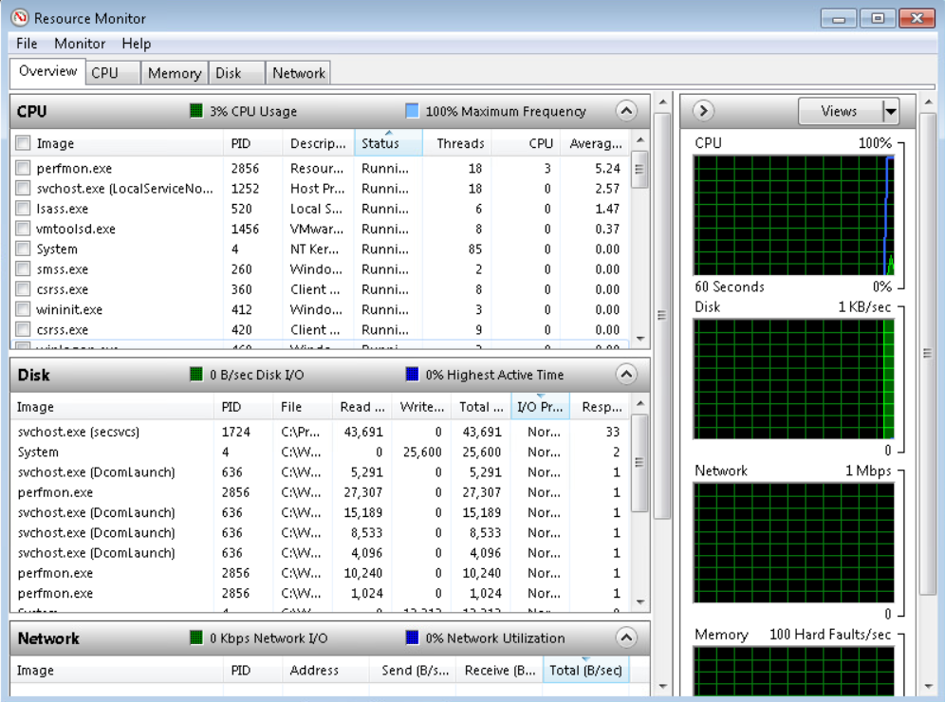
  + System Info
  + 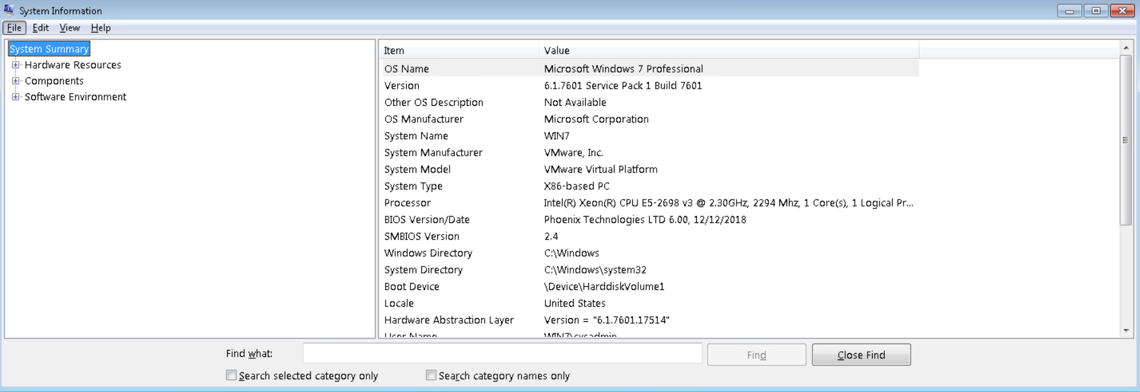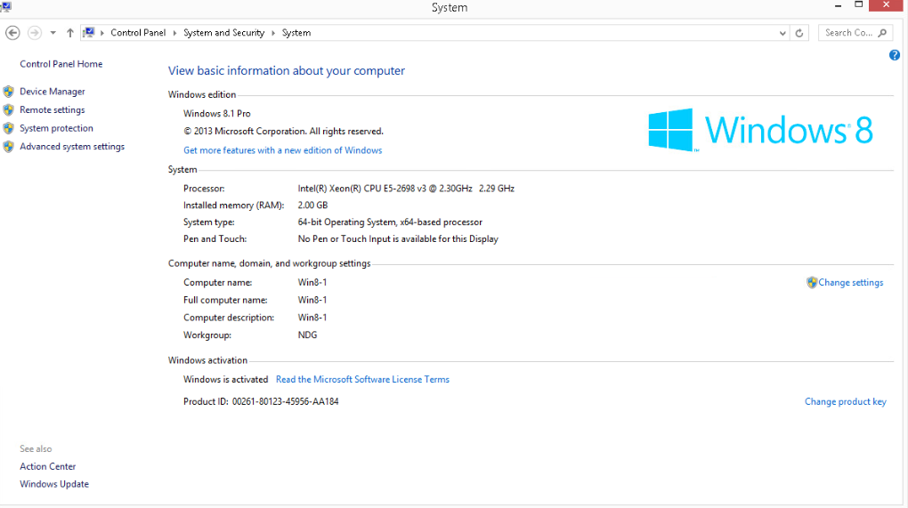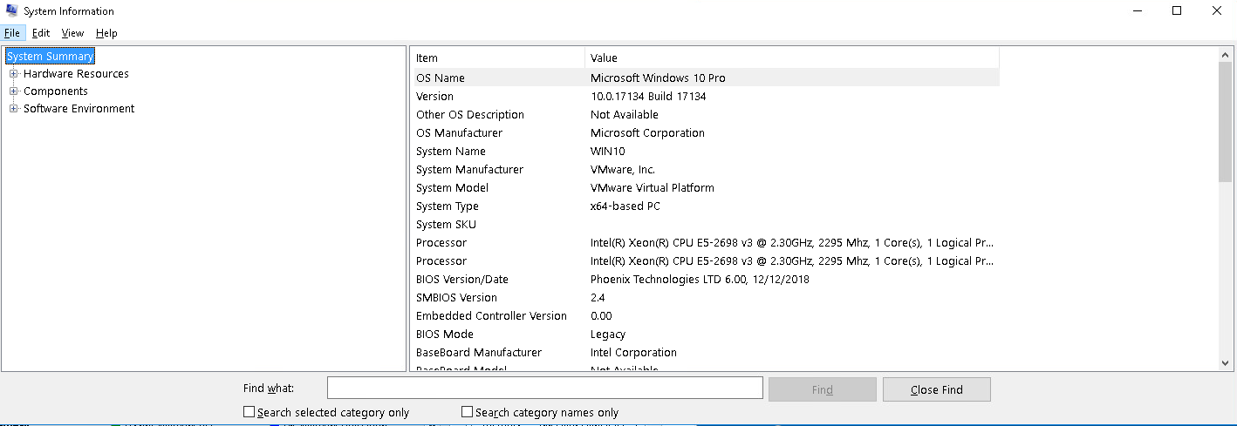
* Gather hardware information using the command line  
  + Research 10 commands that can be run from the command line (ex wmic, systeminfo)
    - systeminfo, wmic cpu get name | NumberOfCores | NumberOfLogicalProcessors, wmic memorychip get capacity | speed, wmic diskdrive get model | size, wmic logicaldisk get name | filesystem | size | freespace, wmic bios get manufacturer | smbiosbiosversion | serialnumber, wmic nic get name | speed, wmic sounddev get name, driverquery, powershell Get-computerInfo

#### Part B: Log on to "EACH" system in [NISGTC Linux+ Series 1, Lab](https://netlabve2.flc.losrios.edu/)

#### [Links to an external site.](https://netlabve2.flc.losrios.edu/)1<https://netlabve2.flc.losrios.edu/>

* Research 10 commands that can be run from the Linux Terminal and run them on "EACH" system
* Lscpu, lsblk, lspci, lsusb, free -h, df -h, uname -a, cat /proc/version, cat /proc/cpuinfo, cat /proc/meminfo
* Fedora Workstation: Consoles logs: 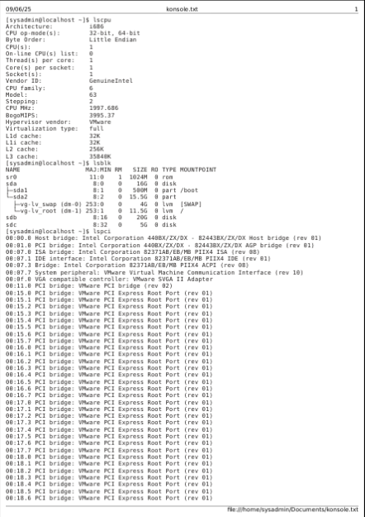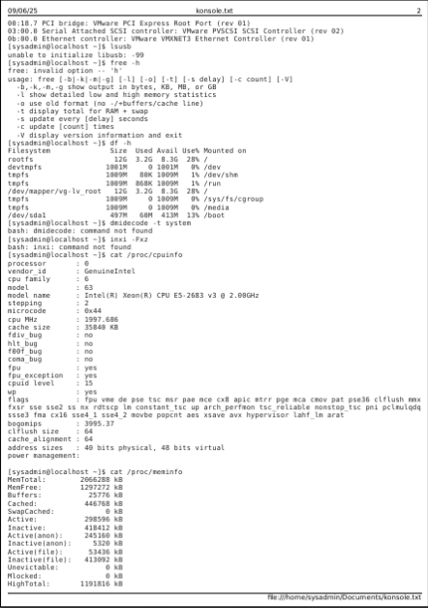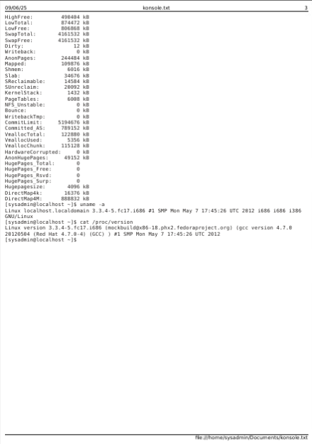
* Ubuntu Workstation: 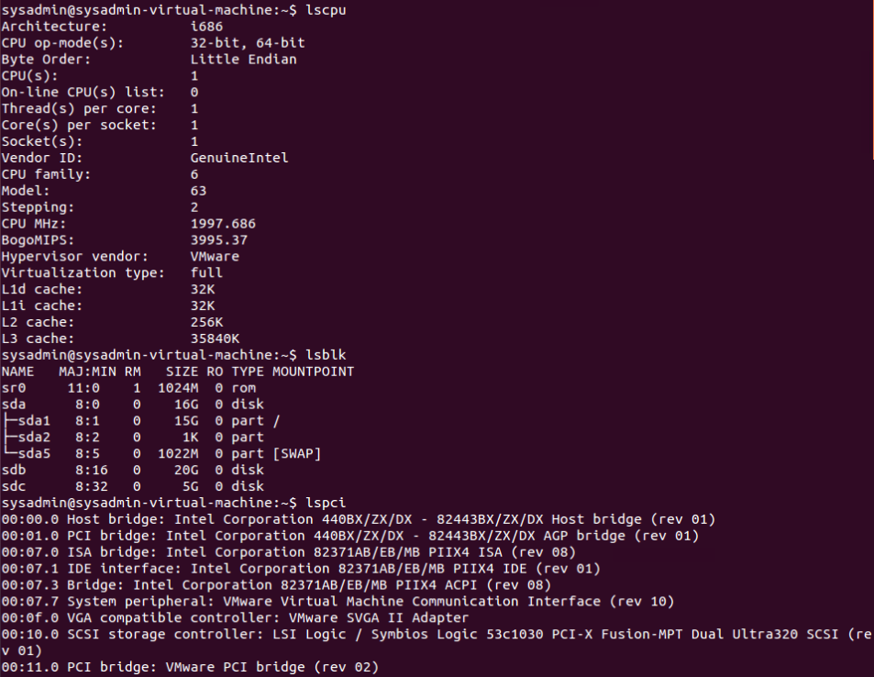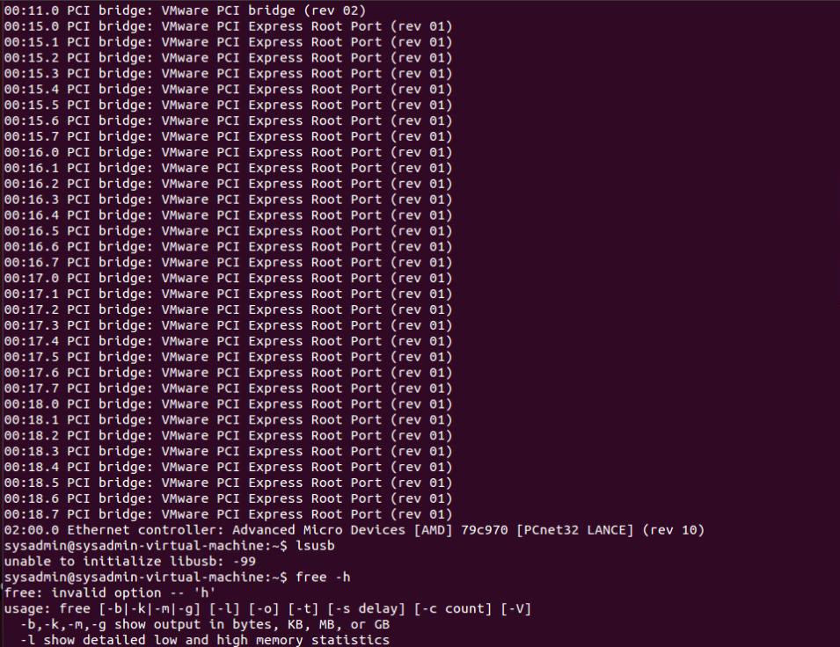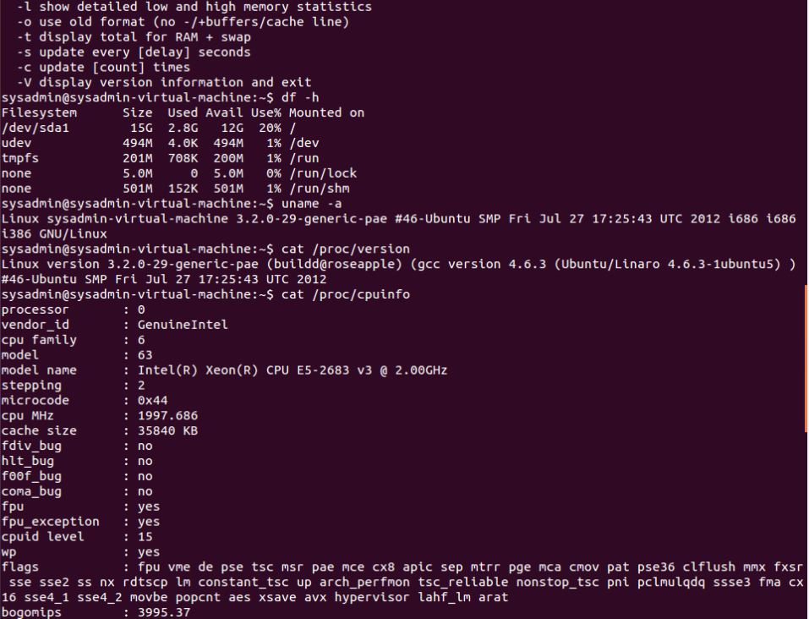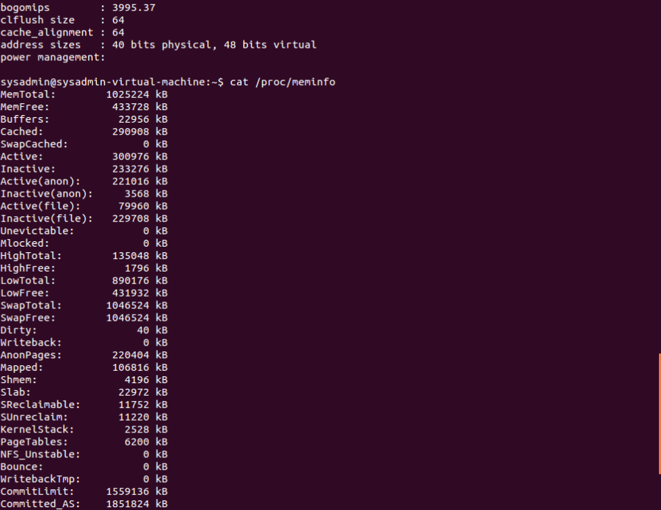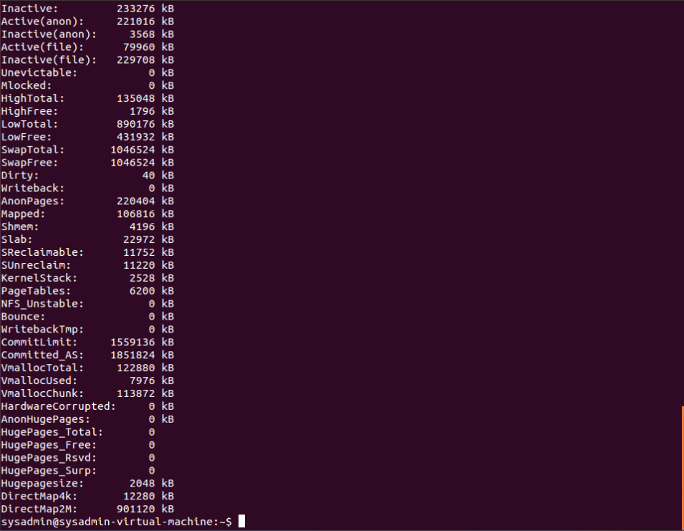
* CentOs Server: 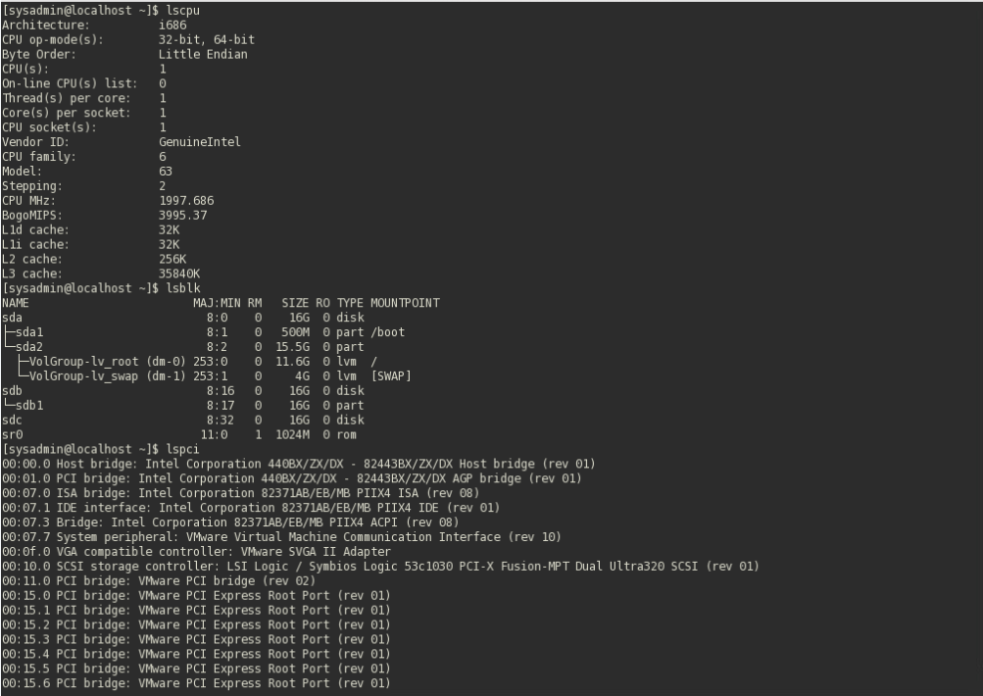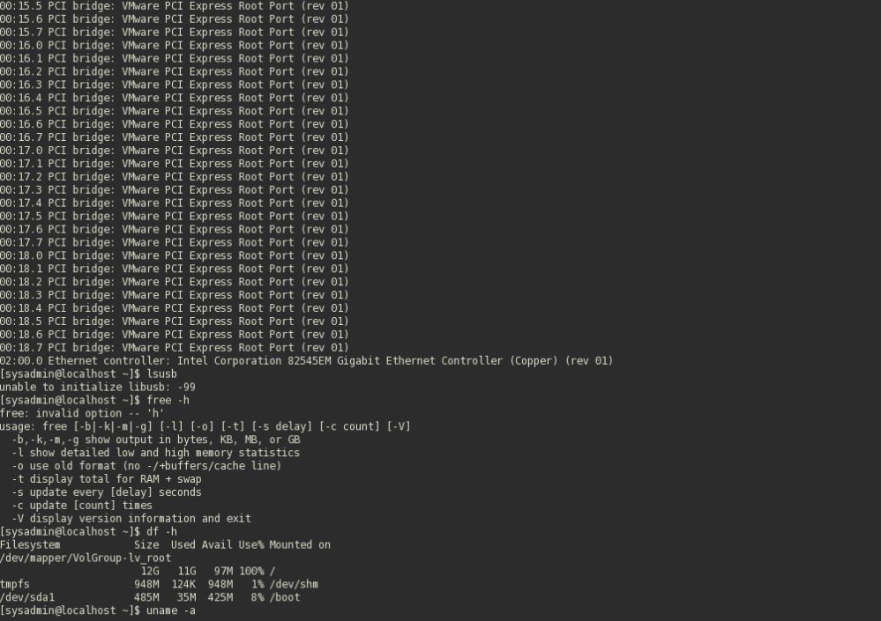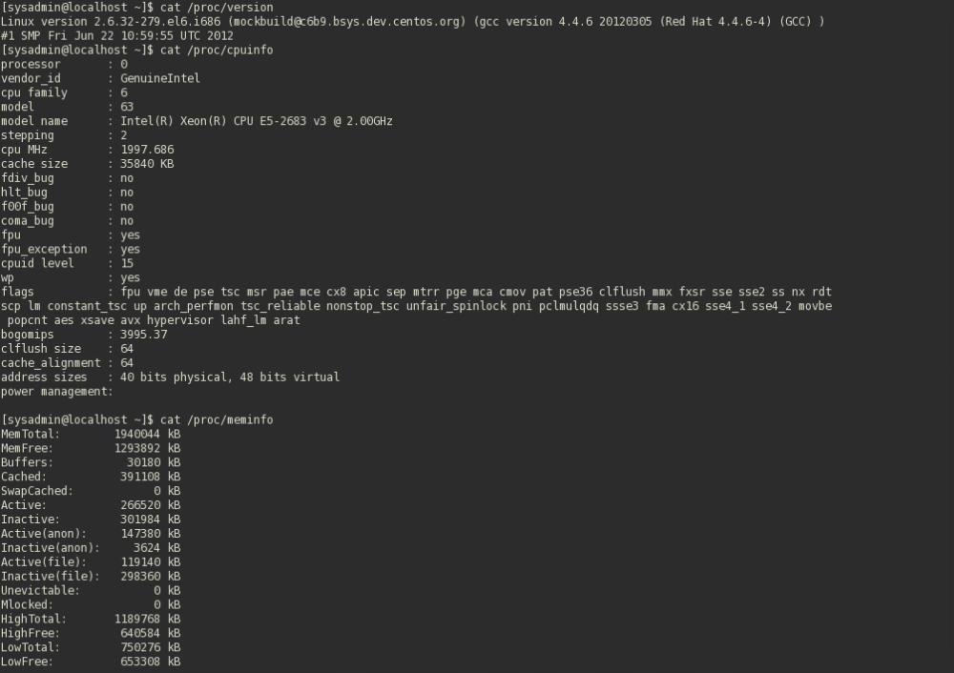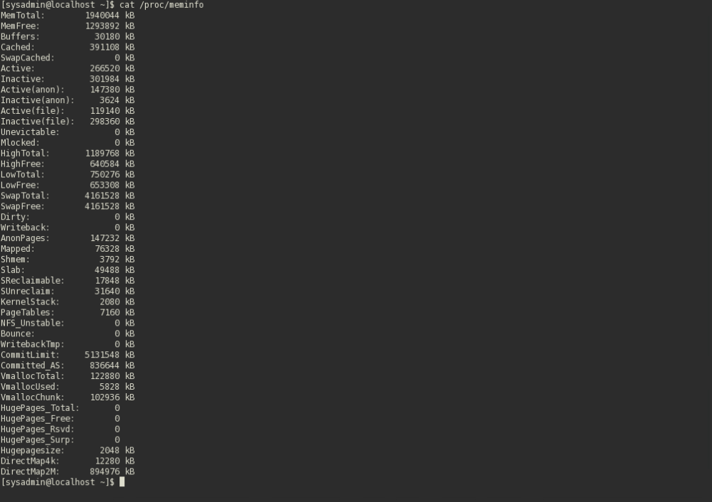
* Ubuntu Server: 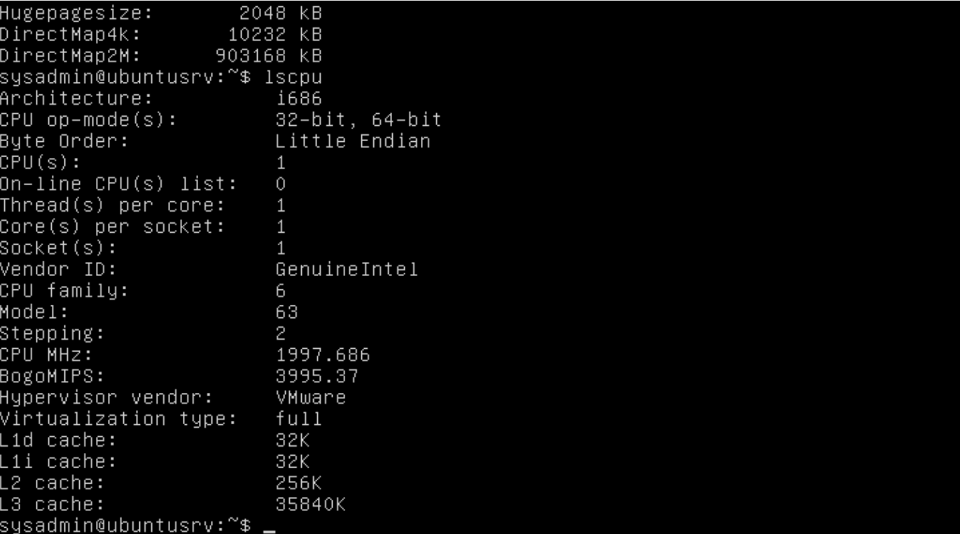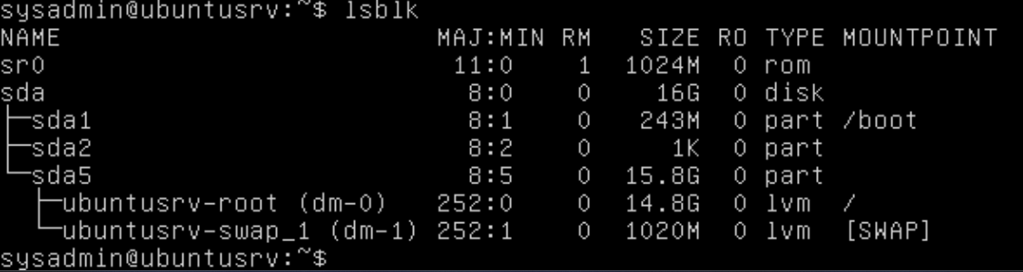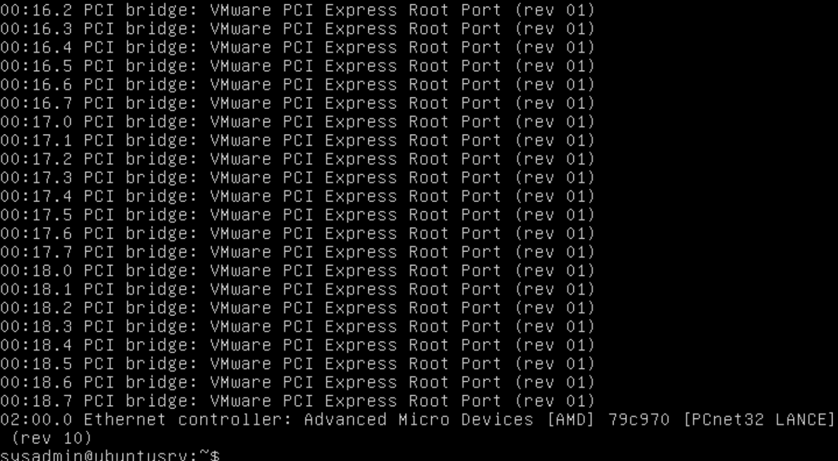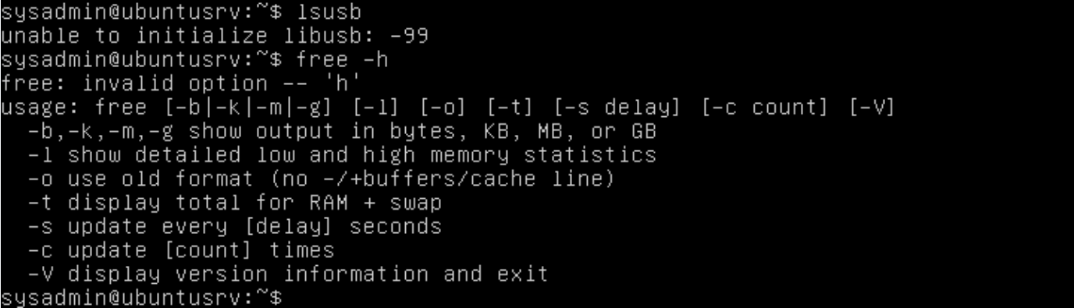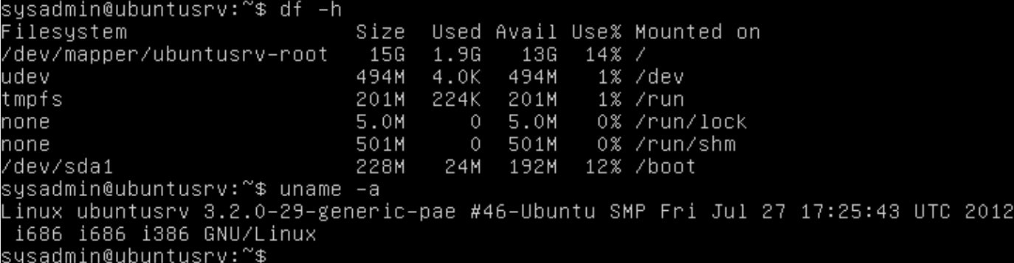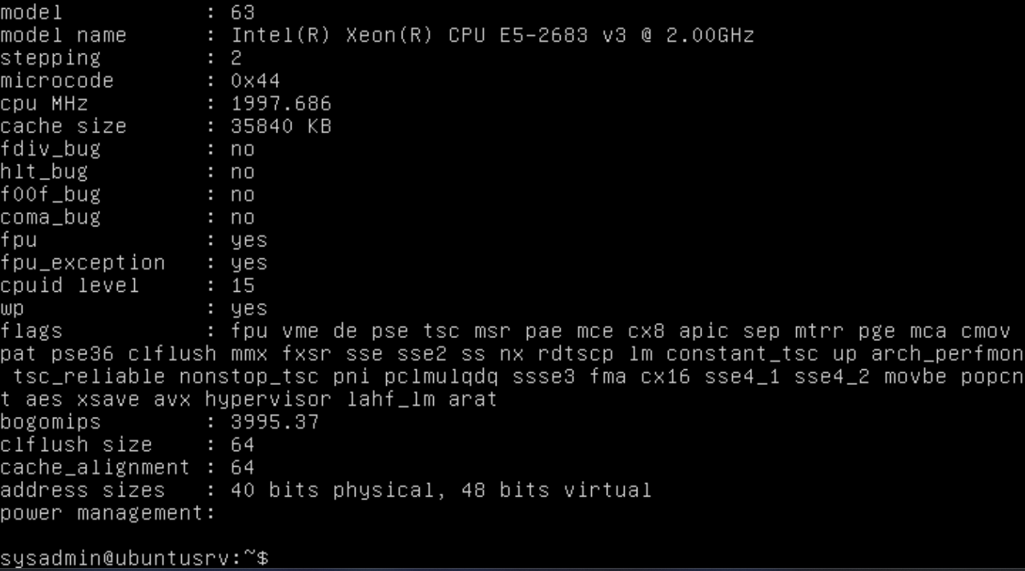

#### Part C:

* On the computer that you are doing this assignment on, gather hardware information:
  + if you are using a MAC, research how to get hardware info (GUI and command line)
  + if you are using Windows, use PowerShell to get your hardware info (research)
  + PowerShell logs below (easier than a million screenshots of terminal)

| Windows PowerShell Copyright (C) Microsoft Corporation. All rights reserved. Install the latest PowerShell for new features and improvements! https://aka.ms/PSWindowsPS C:\WINDOWS\system32> Get-ComputerInfo  WindowsBuildLabEx : 26100.1.amd64fre.ge_release.240331-1435 WindowsCurrentVersion : 6.3 WindowsEditionId : Core WindowsInstallationType : Client WindowsInstallDateFromRegistry : 8/27/2025 2:32:02 AM WindowsProductId : 00326-10000-00000-AA912 WindowsProductName : Windows 10 Home WindowsRegisteredOrganization : WindowsRegisteredOwner : nathan.sipple1@gmail.com WindowsSystemRoot : C:\WINDOWS WindowsVersion : 2009 OSDisplayVersion : 24H2 BiosCharacteristics : {7, 11, 12, 15...} BiosBIOSVersion : {ALASKA - 1072009, F3, American Megatrends - 50011} BiosBuildNumber : BiosCaption : F3 BiosCodeSet : BiosCurrentLanguage : en|US|iso8859-1 BiosDescription : F3 BiosEmbeddedControllerMajorVersion : 255 BiosEmbeddedControllerMinorVersion : 255 BiosFirmwareType : Uefi BiosIdentificationCode : BiosInstallableLanguages : 15 BiosInstallDate : BiosLanguageEdition : BiosListOfLanguages : {en|US|iso8859-1, zh|TW|unicode, zh|CN|unicode,  ru|RU|iso8859-5...} BiosManufacturer : American Megatrends International, LLC. BiosName : F3 BiosOtherTargetOS : BiosPrimaryBIOS : True BiosReleaseDate : 3/21/2024 5:00:00 PM BiosSeralNumber : Default string BiosSMBIOSBIOSVersion : F3 BiosSMBIOSMajorVersion : 3 BiosSMBIOSMinorVersion : 3 BiosSMBIOSPresent : True BiosSoftwareElementState : Running BiosStatus : OK BiosSystemBiosMajorVersion : 5 BiosSystemBiosMinorVersion : 17 BiosTargetOperatingSystem : 0 BiosVersion : ALASKA - 1072009 CsAdminPasswordStatus : Unknown CsAutomaticManagedPagefile : True CsAutomaticResetBootOption : True CsAutomaticResetCapability : True CsBootOptionOnLimit : CsBootOptionOnWatchDog : CsBootROMSupported : True CsBootStatus : {0, 0, 0, 0...} CsBootupState : Normal boot CsCaption : NATHAN_PC CsChassisBootupState : Safe CsChassisSKUNumber : Default string CsCurrentTimeZone : -420 CsDaylightInEffect : True CsDescription : AT/AT COMPATIBLE CsDNSHostName : Nathan_PC CsDomain : WORKGROUP CsDomainRole : StandaloneWorkstation CsEnableDaylightSavingsTime : True CsFrontPanelResetStatus : Unknown CsHypervisorPresent : False CsInfraredSupported : False CsInitialLoadInfo : CsInstallDate : CsKeyboardPasswordStatus : Unknown CsLastLoadInfo : CsManufacturer : Gigabyte Technology Co., Ltd. CsModel : B450M DS3H WIFI CsName : NATHAN_PC CsNetworkAdapters : {Wi-Fi, Bluetooth Network Connection, Ethernet} CsNetworkServerModeEnabled : True CsNumberOfLogicalProcessors : 16 CsNumberOfProcessors : 1 CsProcessors : {AMD Ryzen 7 5700X 8-Core Processor } CsOEMStringArray : {Default string} CsPartOfDomain : False CsPauseAfterReset : -1 CsPCSystemType : Desktop CsPCSystemTypeEx : Desktop CsPowerManagementCapabilities : CsPowerManagementSupported : CsPowerOnPasswordStatus : Unknown CsPowerState : Unknown CsPowerSupplyState : Safe CsPrimaryOwnerContact : CsPrimaryOwnerName : nathan.sipple1@gmail.com CsResetCapability : Other CsResetCount : -1 CsResetLimit : -1 CsRoles : {LM_Workstation, LM_Server, NT} CsStatus : OK CsSupportContactDescription : CsSystemFamily : B450 MB CsSystemSKUNumber : Default string CsSystemType : x64-based PC CsThermalState : Safe CsTotalPhysicalMemory : 34277265408 CsPhyicallyInstalledMemory : 33554432 CsUserName : Nathan_PC\natha CsWakeUpType : PCIPME CsWorkgroup : WORKGROUP OsName : Microsoft Windows 11 Home OsType : WINNT OsOperatingSystemSKU : WindowsHome OsVersion : 10.0.26100 OsCSDVersion : OsBuildNumber : 26100 OsHotFixes : {KB5056579, KB5050575, KB5059093, KB5063878...} OsBootDevice : \Device\HarddiskVolume6 OsSystemDevice : \Device\HarddiskVolume3 OsSystemDirectory : C:\WINDOWS\system32 OsSystemDrive : C: OsWindowsDirectory : C:\WINDOWS OsCountryCode : 1 OsCurrentTimeZone : -420 OsLocaleID : 0409 OsLocale : en-US OsLocalDateTime : 9/6/2025 12:41:30 PM OsLastBootUpTime : 9/5/2025 3:23:45 PM OsUptime : 21:17:44.4390292 OsBuildType : Multiprocessor Free OsCodeSet : 1252 OsDataExecutionPreventionAvailable : True OsDataExecutionPrevention32BitApplications : True OsDataExecutionPreventionDrivers : True OsDataExecutionPreventionSupportPolicy : OptIn OsDebug : False OsDistributed : False OsEncryptionLevel : 256 OsForegroundApplicationBoost : Maximum OsTotalVisibleMemorySize : 33473892 OsFreePhysicalMemory : 22430988 OsTotalVirtualMemorySize : 35571044 OsFreeVirtualMemory : 19439472 OsInUseVirtualMemory : 16131572 OsTotalSwapSpaceSize : OsSizeStoredInPagingFiles : 2097152 OsFreeSpaceInPagingFiles : 2009872 OsPagingFiles : {C:\pagefile.sys} OsHardwareAbstractionLayer : 10.0.26100.1 OsInstallDate : 8/26/2025 7:32:02 PM OsManufacturer : Microsoft Corporation OsMaxNumberOfProcesses : 4294967295 OsMaxProcessMemorySize : 137438953344 OsMuiLanguages : {en-US} OsNumberOfLicensedUsers : OsNumberOfProcesses : 218 OsNumberOfUsers : 2 OsOrganization : OsArchitecture : 64-bit OsLanguage : en-US OsProductSuites : {TerminalServicesSingleSession, HomeEdition} OsOtherTypeDescription : OsPAEEnabled : OsPortableOperatingSystem : False OsPrimary : True OsProductType : WorkStation OsRegisteredUser : nathan.sipple1@gmail.com OsSerialNumber : 00326-10000-00000-AA912 OsServicePackMajorVersion : 0 OsServicePackMinorVersion : 0 OsStatus : OK OsSuites : {TerminalServices, TerminalServicesSingleSession,  HomeEdition} OsServerLevel : KeyboardLayout : en-US TimeZone : (UTC-08:00) Pacific Time (US & Canada) LogonServer : \\NATHAN_PC PowerPlatformRole : Desktop HyperVisorPresent : False HyperVRequirementDataExecutionPreventionAvailable : True HyperVRequirementSecondLevelAddressTranslation : True HyperVRequirementVirtualizationFirmwareEnabled : True HyperVRequirementVMMonitorModeExtensions : True DeviceGuardSmartStatus : Off DeviceGuardRequiredSecurityProperties : DeviceGuardAvailableSecurityProperties : DeviceGuardSecurityServicesConfigured : DeviceGuardSecurityServicesRunning : DeviceGuardCodeIntegrityPolicyEnforcementStatus : EnforcementMode DeviceGuardUserModeCodeIntegrityPolicyEnforcementStatus : AuditMode    PS C:\WINDOWS\system32> Get-WmiObject Win32_Processor   Caption : AMD64 Family 25 Model 33 Stepping 2 DeviceID : CPU0 Manufacturer : AuthenticAMD MaxClockSpeed : 3401 Name : AMD Ryzen 7 5700X 8-Core Processor SocketDesignation : AM4    PS C:\WINDOWS\system32> Get-WmiObject Win32_PhysicalMemory^C PS C:\WINDOWS\system32> Get-WmiObject Win32_PhysicalMemory   __GENUS : 2 __CLASS : Win32_PhysicalMemory __SUPERCLASS : CIM_PhysicalMemory __DYNASTY : CIM_ManagedSystemElement __RELPATH : Win32_PhysicalMemory.Tag="Physical Memory 0" __PROPERTY_COUNT : 36 __DERIVATION : {CIM_PhysicalMemory, CIM_Chip, CIM_PhysicalComponent, CIM_PhysicalElement...} __SERVER : NATHAN_PC __NAMESPACE : root\cimv2 __PATH : \\NATHAN_PC\root\cimv2:Win32_PhysicalMemory.Tag="Physical Memory 0" Attributes : 2 BankLabel : P0 CHANNEL A Capacity : 17179869184 Caption : Physical Memory ConfiguredClockSpeed : 3200 ConfiguredVoltage : 1200 CreationClassName : Win32_PhysicalMemory DataWidth : 64 Description : Physical Memory DeviceLocator : DIMM 0 FormFactor : 8 HotSwappable : InstallDate : InterleaveDataDepth : InterleavePosition : Manufacturer : Micron Technology MaxVoltage : 1200 MemoryType : 0 MinVoltage : 1200 Model : Name : Physical Memory OtherIdentifyingInfo : PartNumber : CP16G4DFRA32A.M16FE PositionInRow : PoweredOn : Removable : Replaceable : SerialNumber : EA10A576 SKU : SMBIOSMemoryType : 26 Speed : 3200 Status : Tag : Physical Memory 0 TotalWidth : 64 TypeDetail : 16512 Version : PSComputerName : NATHAN_PC  __GENUS : 2 __CLASS : Win32_PhysicalMemory __SUPERCLASS : CIM_PhysicalMemory __DYNASTY : CIM_ManagedSystemElement __RELPATH : Win32_PhysicalMemory.Tag="Physical Memory 2" __PROPERTY_COUNT : 36 __DERIVATION : {CIM_PhysicalMemory, CIM_Chip, CIM_PhysicalComponent, CIM_PhysicalElement...} __SERVER : NATHAN_PC __NAMESPACE : root\cimv2 __PATH : \\NATHAN_PC\root\cimv2:Win32_PhysicalMemory.Tag="Physical Memory 2" Attributes : 2 BankLabel : P0 CHANNEL B Capacity : 17179869184 Caption : Physical Memory ConfiguredClockSpeed : 3200 ConfiguredVoltage : 1200 CreationClassName : Win32_PhysicalMemory DataWidth : 64 Description : Physical Memory DeviceLocator : DIMM 0 FormFactor : 8 HotSwappable : InstallDate : InterleaveDataDepth : InterleavePosition : Manufacturer : Micron Technology MaxVoltage : 1200 MemoryType : 0 MinVoltage : 1200 Model : Name : Physical Memory OtherIdentifyingInfo : PartNumber : CP16G4DFRA32A.M16FE PositionInRow : PoweredOn : Removable : Replaceable : SerialNumber : EA10A4BF SKU : SMBIOSMemoryType : 26 Speed : 3200 Status : Tag : Physical Memory 2 TotalWidth : 64 TypeDetail : 16512 Version : PSComputerName : NATHAN_PC    PS C:\WINDOWS\system32> Get-WmiObject Win32_DiskDrive   Partitions : 4 DeviceID : \\.\PHYSICALDRIVE1 Model : SAMSUNG MZNLN128HAHQ-000H1 Size : 128034708480 Caption : SAMSUNG MZNLN128HAHQ-000H1  Partitions : 1 DeviceID : \\.\PHYSICALDRIVE0 Model : CT2000BX500SSD1 Size : 2000396321280 Caption : CT2000BX500SSD1    PS C:\WINDOWS\system32> Get-WmiObject Win32_VideoController   __GENUS : 2 __CLASS : Win32_VideoController __SUPERCLASS : CIM_PCVideoController __DYNASTY : CIM_ManagedSystemElement __RELPATH : Win32_VideoController.DeviceID="VideoController1" __PROPERTY_COUNT : 59 __DERIVATION : {CIM_PCVideoController, CIM_VideoController, CIM_Controller, CIM_LogicalDevice...} __SERVER : NATHAN_PC __NAMESPACE : root\cimv2 __PATH : \\NATHAN_PC\root\cimv2:Win32_VideoController.DeviceID="VideoController1" AcceleratorCapabilities : AdapterCompatibility : NVIDIA AdapterDACType : Integrated RAMDAC AdapterRAM : 4293918720 Availability : 3 CapabilityDescriptions : Caption : NVIDIA GeForce RTX 2060 ColorTableEntries : ConfigManagerErrorCode : 0 ConfigManagerUserConfig : False CreationClassName : Win32_VideoController CurrentBitsPerPixel : 32 CurrentHorizontalResolution : 1920 CurrentNumberOfColors : 4294967296 CurrentNumberOfColumns : 0 CurrentNumberOfRows : 0 CurrentRefreshRate : 60 CurrentScanMode : 4 CurrentVerticalResolution : 1080 Description : NVIDIA GeForce RTX 2060 DeviceID : VideoController1 DeviceSpecificPens : DitherType : 0 DriverDate : 20250821000000.000000-000 DriverVersion : 32.0.15.8115 ErrorCleared : ErrorDescription : ICMIntent : ICMMethod : InfFilename : oem13.inf InfSection : Section001 InstallDate : InstalledDisplayDrivers : C:\WINDOWS\System32\DriverStore\FileRepository\nv_dispi.inf_amd64_3496fbfac7a2d1ba\nvldu  mdx.dll,C:\WINDOWS\System32\DriverStore\FileRepository\nv_dispi.inf_amd64_3496fbfac7a2d1  ba\nvldumdx.dll,C:\WINDOWS\System32\DriverStore\FileRepository\nv_dispi.inf_amd64_3496fb  fac7a2d1ba\nvldumdx.dll,C:\WINDOWS\System32\DriverStore\FileRepository\nv_dispi.inf_amd6  4_3496fbfac7a2d1ba\nvldumdx.dll LastErrorCode : MaxMemorySupported : MaxNumberControlled : MaxRefreshRate : 120 MinRefreshRate : 23 Monochrome : False Name : NVIDIA GeForce RTX 2060 NumberOfColorPlanes : NumberOfVideoPages : PNPDeviceID : PCI\VEN_10DE&DEV_1E89&SUBSYS_87951043&REV_A1\4&1FC990D7&0&0019 PowerManagementCapabilities : PowerManagementSupported : ProtocolSupported : ReservedSystemPaletteEntries : SpecificationVersion : Status : OK StatusInfo : SystemCreationClassName : Win32_ComputerSystem SystemName : NATHAN_PC SystemPaletteEntries : TimeOfLastReset : VideoArchitecture : 5 VideoMemoryType : 2 VideoMode : VideoModeDescription : 1920 x 1080 x 4294967296 colors VideoProcessor : NVIDIA GeForce RTX 2060 PSComputerName : NATHAN_PC    PS C:\WINDOWS\system32> Get-WmiObject Win32_NetworkAdapter   ServiceName : RTWlanE MACAddress : 28:D0:43:D7:97:6F AdapterType : Ethernet 802.3 DeviceID : 0 Name : Realtek 8821CE Wireless LAN 802.11ac PCI-E NIC NetworkAddresses : Speed : 72200000  ServiceName : BthPan MACAddress : 28:D0:43:D7:97:6E AdapterType : Ethernet 802.3 DeviceID : 1 Name : Bluetooth Device (Personal Area Network) NetworkAddresses : Speed : 3000000  ServiceName : rt640x64 MACAddress : 10:FF:E0:74:6F:19 AdapterType : Ethernet 802.3 DeviceID : 2 Name : Realtek PCIe GbE Family Controller NetworkAddresses : Speed : 1000000000  ServiceName : kdnic MACAddress : AdapterType : DeviceID : 3 Name : Microsoft Kernel Debug Network Adapter NetworkAddresses : Speed :  ServiceName : vwifimp MACAddress : 2A:D0:43:D7:97:6F AdapterType : Ethernet 802.3 DeviceID : 4 Name : Microsoft Wi-Fi Direct Virtual Adapter NetworkAddresses : Speed : 9223372036854775807  ServiceName : vwifimp MACAddress : AA:D0:43:D7:97:6F AdapterType : Ethernet 802.3 DeviceID : 5 Name : Microsoft Wi-Fi Direct Virtual Adapter #2 NetworkAddresses : Speed : 9223372036854775807  ServiceName : RasSstp MACAddress : AdapterType : DeviceID : 6 Name : WAN Miniport (SSTP) NetworkAddresses : Speed :  ServiceName : RasAgileVpn MACAddress : AdapterType : DeviceID : 7 Name : WAN Miniport (IKEv2) NetworkAddresses : Speed :  ServiceName : Rasl2tp MACAddress : AdapterType : DeviceID : 8 Name : WAN Miniport (L2TP) NetworkAddresses : Speed :  ServiceName : PptpMiniport MACAddress : AdapterType : DeviceID : 9 Name : WAN Miniport (PPTP) NetworkAddresses : Speed :  ServiceName : RasPppoe MACAddress : AdapterType : DeviceID : 10 Name : WAN Miniport (PPPOE) NetworkAddresses : Speed :  ServiceName : NdisWan MACAddress : BC:83:20:52:41:53 AdapterType : Ethernet 802.3 DeviceID : 11 Name : WAN Miniport (IP) NetworkAddresses : Speed :  ServiceName : NdisWan MACAddress : BC:4C:20:52:41:53 AdapterType : Ethernet 802.3 DeviceID : 12 Name : WAN Miniport (IPv6) NetworkAddresses : Speed :  ServiceName : NdisWan MACAddress : BC:C9:20:52:41:53 AdapterType : Ethernet 802.3 DeviceID : 13 Name : WAN Miniport (Network Monitor) NetworkAddresses : Speed :    PS C:\WINDOWS\system32> |
| --- |

#### BONUS: 5 points

* Find hardware information on your cell phone using built-in tools
* 